МИНИСТЕРСТВО НАУКИ И ВЫСШЕГО ОБРАЗОВАНИЯ РОССИЙСКОЙ ФЕДЕРАЦИИ

Федеральное государственное бюджетное образовательное учреждение высшего образования

«Казанский национальный исследовательский технический университет

им. А.Н. Туполева – КАИ»

Институт компьютерных технологий и защиты информации

Отделение СПО ИКТЗИ (Колледж информационных технологий)

ЛАБОРАТОРНАЯ РАБОТА №4

по дисциплине

Разработка программных модулей

Тема: «Классы Path и Geometry»

Работу выполнил

Студент гр.4335

Желваков А. С.

Принял

Преподаватель

Лоповок Е. Е.

Казань 2024

**Задание на лабораторную работу**

1. Разработать WPF-приложение «Дорожные знаки».
2. Разработать приложение «Карусель товаров».

**Результат выполнения работы**

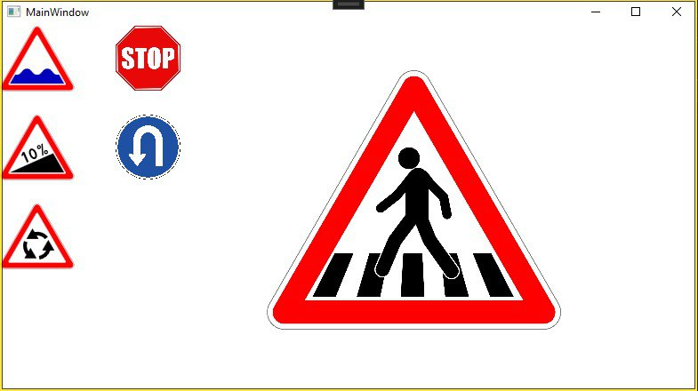Рис. 1.1 – Выполнение первого задания

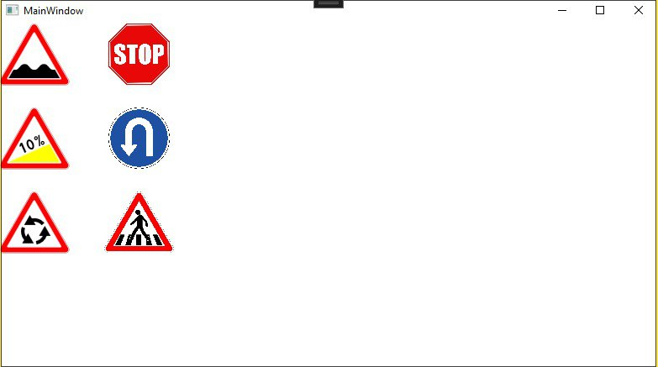Рис. 1.2 - Выполнение первого задания

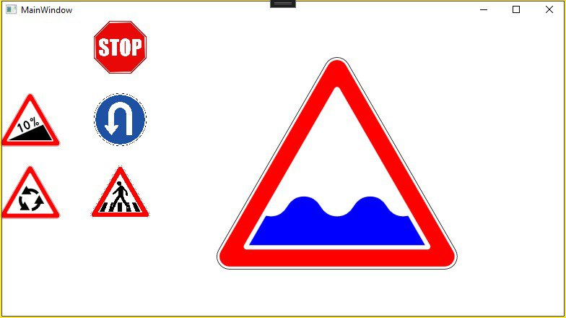Рис. 1.3 - Выполнение первого задания

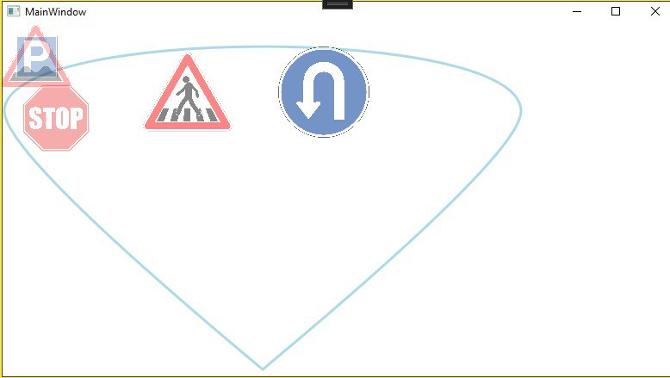Рис. 2.1 – Выполнение второго задания

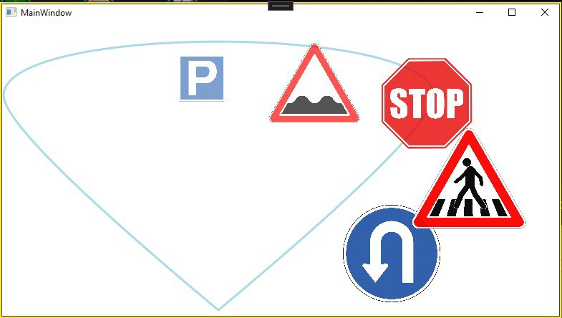Рис. 2.2 - Выполнение второго задания

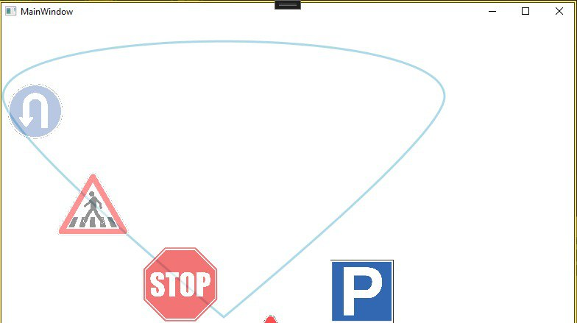Рис. 2.3 - Выполнение второго задания

**Листинг программы**

Задание 1:

<Window x:Class="rpm_zhelvakov4_1.MainWindow"

xmlns="http://schemas.microsoft.com/winfx/2006/xaml/presentation"

xmlns:x="http://schemas.microsoft.com/winfx/2006/xaml"

xmlns:d="http://schemas.microsoft.com/expression/blend/2008"

xmlns:mc="http://schemas.openxmlformats.org/markup-compatibility/2006"

xmlns:local="clr-namespace:rpm_zhelvakov4_1"

mc:Ignorable="d"

Title="MainWindow" Height="450" Width="800">

<Window.Resources>

<Storyboard x:Key="onScreenSVG" AutoReverse="True" Duration="0:0:1.5">

<DoubleAnimation

Storyboard.TargetProperty="(Canvas.Left)"

To="300"

Duration="0:0:0.5"/>

<DoubleAnimation

Storyboard.TargetProperty="(Canvas.Top)"

To="50"

Duration="0:0:0.5"/>

<DoubleAnimation

Storyboard.TargetProperty="RenderTransform.ScaleX"

To="0.4"

Duration="0:0:0.5"/>

<DoubleAnimation

Storyboard.TargetProperty="RenderTransform.ScaleY"

To="0.4"

Duration="0:0:0.5"/>

</Storyboard>

<Storyboard x:Key="onScreenIMG" AutoReverse="True" Duration="0:0:1.5">

<DoubleAnimation

Storyboard.TargetProperty="(Canvas.Left)"

To="300"

Duration="0:0:0.5"/>

<DoubleAnimation

Storyboard.TargetProperty="(Canvas.Top)"

To="50"

Duration="0:0:0.5"/>

<DoubleAnimation

Storyboard.TargetProperty="RenderTransform.ScaleX"

To="4"

Duration="0:0:0.5"/>

<DoubleAnimation

Storyboard.TargetProperty="RenderTransform.ScaleY"

To="4"

Duration="0:0:0.5"/>

</Storyboard>

<Style TargetType="StackPanel">

<Setter Property="RenderTransform">

<Setter.Value>

<ScaleTransform ScaleX="0.1" ScaleY="0.1"/>

</Setter.Value>

</Setter>

<Style.Triggers>

<EventTrigger RoutedEvent="MouseDown">

<BeginStoryboard Storyboard="{StaticResource onScreenSVG}"/>

</EventTrigger>

</Style.Triggers>

</Style>

<Style TargetType="Image">

<Setter Property="RenderTransform">

<Setter.Value>

<ScaleTransform/>

</Setter.Value>

</Setter>

<Style.Triggers>

<EventTrigger RoutedEvent="MouseDown">

<BeginStoryboard Storyboard="{StaticResource onScreenIMG}"/>

</EventTrigger>

</Style.Triggers>

</Style>

</Window.Resources>

<Canvas>

<StackPanel Canvas.Left="0" Canvas.Top="0">

<Canvas Name="svg213" Width="834.116" Height="734.423">

<Canvas.Resources/>

<!--Unknown tag: metadata-->

<!--Unknown tag: sodipodi:namedview-->

<Path xmlns:x="http://schemas.microsoft.com/winfx/2006/xaml" Name="path205" Fill="#FFFFFFFF">

<Path.Data>

<PathGeometry Figures="m 0 689.423 c 0 24.853 20.147 45 45 45 l 744.116 0 c 24.853 0 45 -20.147 45 -45 c 0 -7.899 -2.079 -15.659 -6.029 -22.5 l -372.058 -644.423 c -8.038 -13.923 -22.894 -22.5 -38.971 -22.5 c -16.077 0 -30.933 8.577 -38.971 22.5 l -372.058 644.423 c -3.950 6.841 -6.029 14.601 -6.029 22.5 z" FillRule="NonZero"/>

</Path.Data>

</Path>

<Path xmlns:x="http://schemas.microsoft.com/winfx/2006/xaml" Name="path207" StrokeThickness="2" Stroke="#FF000000">

<Path.Data>

<PathGeometry Figures="m 1 689.423 c 0 24.301 19.699 44 44 44 l 744.116 0 c 24.301 0 44 -19.699 44 -44 c 0 -7.724 -2.033 -15.311 -5.895 -22.0 l -372.058 -644.423 c -7.860 -13.614 -22.385 -22.0 -38.105 -22.0 c -15.720 0 -30.245 8.386 -38.105 22.0 l -372.058 644.423 c -3.862 6.689 -5.895 14.276 -5.895 22.0 z" FillRule="NonZero"/>

</Path.Data>

</Path>

<Path xmlns:x="http://schemas.microsoft.com/winfx/2006/xaml" Name="path209" Fill="#FFFF0000">

<Path.Data>

<PathGeometry Figures="m 10 689.423 c 0 19.330 15.670 35 35 35 l 744.116 0 c 19.330 0 35 -15.670 35 -35 c 0 -6.144 -1.617 -12.179 -4.689 -17.5 l -372.058 -644.423 c -6.252 -10.829 -17.807 -17.5 -30.311 -17.5 c -12.504 0 -24.059 6.671 -30.311 17.5 l -372.058 644.423 c -3.072 5.321 -4.689 11.357 -4.689 17.5 z m 83.634 -33.852 c 0 -1.755 0.462 -3.480 1.340 -5.000 l 313.424 -542.866 c 1.786 -3.094 5.087 -5 8.660 -5.000 c 3.573 0 6.873 1.906 8.660 5.000 l 313.424 542.866 c 0.878 1.520 1.340 3.245 1.340 5.000 c 0 5.523 -4.477 10 -10 10 l -626.848 0 c -5.523 0 -10 -4.477 -10 -10 z" FillRule="NonZero"/>

</Path.Data>

</Path>

<Path xmlns:x="http://schemas.microsoft.com/winfx/2006/xaml" Name="wave" Fill="#FF000000">

<Path.Data>

<PathGeometry Figures="m 112.153 650.653 l 58.769 -101.792 c 5.128 1.272 10.663 1.956 16.629 1.956 c 27.541 0 45.901 -14.550 57.377 -34.426 c 11.475 -19.876 29.836 -34.426 57.376 -34.426 c 27.541 0 45.902 14.550 57.377 34.426 c 11.476 19.876 29.836 34.426 57.377 34.426 c 27.541 0 45.901 -14.550 57.377 -34.426 c 11.475 -19.876 29.836 -34.426 57.377 -34.426 c 27.540 0 45.901 14.550 57.376 34.426 c 11.476 19.876 29.836 34.426 57.377 34.426 c 5.966 0 11.501 -0.684 16.629 -1.956 l 58.769 101.792 z" FillRule="NonZero"/>

</Path.Data>

</Path>

<Canvas.Triggers>

<EventTrigger RoutedEvent="MouseEnter">

<BeginStoryboard>

<Storyboard>

<ColorAnimation

Storyboard.TargetName="wave"

Storyboard.TargetProperty="Fill.(SolidColorBrush.Color)"

To="Blue"

Duration="0:0:0.5"/>

</Storyboard>

</BeginStoryboard>

</EventTrigger>

<EventTrigger RoutedEvent="MouseLeave">

<BeginStoryboard>

<Storyboard>

<ColorAnimation

Storyboard.TargetName="wave"

Storyboard.TargetProperty="Fill.(SolidColorBrush.Color)"

Duration="0:0:0.5"/>

</Storyboard>

</BeginStoryboard>

</EventTrigger>

</Canvas.Triggers>

</Canvas>

</StackPanel>

<Image Source="/pngwing.com.png" Width="83" Height="73" Canvas.Left="125" Canvas.Top="0"/>

<StackPanel Canvas.Left="0" Canvas.Top="100">

<Canvas Name="svg97" Width="834.116" Height="734.423">

<Canvas.Resources/>

<!--Unknown tag: metadata-->

<!--Unknown tag: sodipodi:namedview-->

<Path xmlns:x="http://schemas.microsoft.com/winfx/2006/xaml" Name="path79" Fill="#FFFFFFFF">

<Path.Data>

<PathGeometry Figures="m 0 689.423 c 0 24.853 20.147 45 45 45 l 744.116 0 c 24.853 0 45 -20.147 45 -45 c 0 -7.899 -2.079 -15.659 -6.029 -22.5 l -372.058 -644.423 c -8.038 -13.923 -22.894 -22.5 -38.971 -22.5 c -16.077 0 -30.933 8.577 -38.971 22.5 l -372.058 644.423 c -3.950 6.841 -6.029 14.601 -6.029 22.5 z" FillRule="NonZero"/>

</Path.Data>

</Path>

<Path xmlns:x="http://schemas.microsoft.com/winfx/2006/xaml" Name="path81" StrokeThickness="2" Stroke="#FF000000">

<Path.Data>

<PathGeometry Figures="m 1 689.423 c 0 24.301 19.699 44 44 44 l 744.116 0 c 24.301 0 44 -19.699 44 -44 c 0 -7.724 -2.033 -15.311 -5.895 -22.0 l -372.058 -644.423 c -7.860 -13.614 -22.385 -22.0 -38.105 -22.0 c -15.720 0 -30.245 8.386 -38.105 22.0 l -372.058 644.423 c -3.862 6.689 -5.895 14.276 -5.895 22.0 z" FillRule="NonZero"/>

</Path.Data>

</Path>

<Path xmlns:x="http://schemas.microsoft.com/winfx/2006/xaml" Name="path83" Fill="#FFFF0000">

<Path.Data>

<PathGeometry Figures="m 10 689.423 c 0 19.330 15.670 35 35 35 l 744.116 0 c 19.330 0 35 -15.670 35 -35 c 0 -6.144 -1.617 -12.179 -4.689 -17.5 l -372.058 -644.423 c -6.252 -10.829 -17.807 -17.5 -30.311 -17.5 c -12.504 0 -24.059 6.671 -30.311 17.5 l -372.058 644.423 c -3.072 5.321 -4.689 11.357 -4.689 17.5 z m 83.634 -33.852 c 0 -1.755 0.462 -3.480 1.340 -5.000 l 313.424 -542.866 c 1.786 -3.094 5.087 -5 8.660 -5.000 c 3.573 0 6.873 1.906 8.660 5.000 l 313.424 542.866 c 0.878 1.520 1.340 3.245 1.340 5.000 c 0 5.523 -4.477 10 -10 10 l -626.848 0 c -5.523 0 -10 -4.477 -10 -10 z" FillRule="NonZero"/>

</Path.Data>

</Path>

<Path xmlns:x="http://schemas.microsoft.com/winfx/2006/xaml" Name="triangle" Fill="#FF000000">

<Path.Data>

<PathGeometry Figures="m 112.152 650.653 l 485.112 -215.986 l 124.699 215.986 z" FillRule="NonZero"/>

</Path.Data>

</Path>

<Path xmlns:x="http://schemas.microsoft.com/winfx/2006/xaml" Name="path87" Fill="#FF000000">

<Path.Data>

<PathGeometry Figures="m 240.811 459.822 l 9.293 8.134 l 13.019 -17.324 l 39.311 88.295 l 20.173 -8.981 l -50.642 -113.743 l -19.552 8.705 z" FillRule="NonZero"/>

</Path.Data>

</Path>

<Path xmlns:x="http://schemas.microsoft.com/winfx/2006/xaml" Name="path89" Fill="#FF000000">

<Path.Data>

<PathGeometry Figures="m 407.486 423.916 c 7.093 15.931 9.528 31.179 7.304 45.742 c -2.224 14.563 -8.483 24.137 -18.776 28.719 c -10.035 4.468 -21.302 2.651 -33.803 -5.449 c -12.501 -8.101 -22.263 -20.039 -29.287 -35.815 c -7.070 -15.880 -9.493 -31.101 -7.269 -45.665 c 2.224 -14.563 8.508 -24.148 18.853 -28.754 c 10.138 -4.514 21.401 -2.742 33.790 5.316 c 12.388 8.058 22.118 20.026 29.188 35.906 z m -18.543 8.256 c -4.974 -11.173 -10.967 -19.691 -17.979 -25.556 c -7.012 -5.865 -13.078 -7.657 -18.199 -5.378 c -5.017 2.234 -7.714 7.975 -8.090 17.222 c -0.376 9.247 1.888 19.380 6.794 30.397 c 2.694 6.052 5.431 11.016 8.211 14.891 c 2.779 3.876 6.047 7.457 9.803 10.743 c 7.012 5.865 13.104 7.646 18.276 5.343 c 4.966 -2.211 7.619 -7.979 7.961 -17.304 c 0.342 -9.325 -1.917 -19.444 -6.776 -30.358 z" FillRule="NonZero"/>

</Path.Data>

</Path>

<Path xmlns:x="http://schemas.microsoft.com/winfx/2006/xaml" Name="path91" Fill="#FF000000">

<Path.Data>

<PathGeometry Figures="m 414.256 364.866 c 0 12.675 10.276 22.951 22.951 22.951 c 12.675 0 22.951 -10.276 22.951 -22.951 c 0 -12.675 -10.276 -22.951 -22.951 -22.951 c -12.675 0 -22.951 10.276 -22.951 22.951 z m 12.623 0 c 0 -5.704 4.624 -10.328 10.328 -10.328 c 5.704 0 10.328 4.624 10.328 10.328 c 0 5.704 -4.624 10.328 -10.328 10.328 c -5.704 0 -10.328 -4.624 -10.328 -10.328 z" FillRule="NonZero"/>

</Path.Data>

</Path>

<Path xmlns:x="http://schemas.microsoft.com/winfx/2006/xaml" Name="path93" Fill="#FF000000">

<Path.Data>

<PathGeometry Figures="m 488.783 455.959 l -14.503 6.457 l -9.243 -132.175 l 14.503 -6.457 z" FillRule="NonZero"/>

</Path.Data>

</Path>

<Path xmlns:x="http://schemas.microsoft.com/winfx/2006/xaml" Name="path95" Fill="#FF000000">

<Path.Data>

<PathGeometry Figures="m 493.663 421.335 c 0 12.675 10.276 22.951 22.951 22.951 c 12.675 0 22.951 -10.276 22.951 -22.951 c 0 -12.675 -10.276 -22.951 -22.951 -22.951 c -12.675 0 -22.951 10.276 -22.951 22.951 z m 12.623 0 c 0 -5.704 4.624 -10.328 10.328 -10.328 c 5.704 0 10.328 4.624 10.328 10.328 c 0 5.704 -4.624 10.328 -10.328 10.328 c -5.704 0 -10.328 -4.624 -10.328 -10.328 z" FillRule="NonZero"/>

</Path.Data>

</Path>

<Canvas.Triggers>

<EventTrigger RoutedEvent="MouseEnter">

<BeginStoryboard>

<Storyboard>

<ColorAnimation

Storyboard.TargetName="triangle"

Storyboard.TargetProperty="Fill.(SolidColorBrush.Color)"

To="Yellow"

Duration="0:0:0.5"/>

</Storyboard>

</BeginStoryboard>

</EventTrigger>

<EventTrigger RoutedEvent="MouseLeave">

<BeginStoryboard>

<Storyboard>

<ColorAnimation

Storyboard.TargetName="triangle"

Storyboard.TargetProperty="Fill.(SolidColorBrush.Color)"

Duration="0:0:0.5"/>

</Storyboard>

</BeginStoryboard>

</EventTrigger>

</Canvas.Triggers>

</Canvas>

</StackPanel>

<Image Source="/qwe.png" Width="83" Height="73" Canvas.Left="125" Canvas.Top="100"/>

<StackPanel Canvas.Left="0" Canvas.Top="200">

<Canvas Name="svg3737" Width="834.116" Height="734.423">

<Canvas.RenderTransform>

<TranslateTransform X="0" Y="0"/>

</Canvas.RenderTransform>

<Canvas.Resources/>

<!--Unknown tag: metadata-->

<!--Unknown tag: sodipodi:namedview-->

<Canvas Name="g3735">

<Path xmlns:x="http://schemas.microsoft.com/winfx/2006/xaml" Name="path129" Fill="#FFFFFFFF">

<Path.Data>

<PathGeometry Figures="m 0 689.423 c 0 24.853 20.147 45 45 45 l 744.116 0 c 24.853 0 45 -20.147 45 -45 c 0 -7.899 -2.079 -15.659 -6.029 -22.5 l -372.058 -644.423 c -8.038 -13.923 -22.894 -22.5 -38.971 -22.5 c -16.077 0 -30.933 8.577 -38.971 22.5 l -372.058 644.423 c -3.950 6.841 -6.029 14.601 -6.029 22.5 z" FillRule="NonZero"/>

</Path.Data>

</Path>

<Path xmlns:x="http://schemas.microsoft.com/winfx/2006/xaml" Name="path131" StrokeThickness="2" Stroke="#FF000000">

<Path.Data>

<PathGeometry Figures="m 1 689.423 c 0 24.301 19.699 44 44 44 l 744.116 0 c 24.301 0 44 -19.699 44 -44 c 0 -7.724 -2.033 -15.311 -5.895 -22.0 l -372.058 -644.423 c -7.860 -13.614 -22.385 -22.0 -38.105 -22.0 c -15.720 0 -30.245 8.386 -38.105 22.0 l -372.058 644.423 c -3.862 6.689 -5.895 14.276 -5.895 22.0 z" FillRule="NonZero"/>

</Path.Data>

</Path>

<Path xmlns:x="http://schemas.microsoft.com/winfx/2006/xaml" Name="border" Fill="#FFFF0000">

<Path.Data>

<PathGeometry Figures="m 10 689.423 c 0 19.330 15.670 35 35 35 l 744.116 0 c 19.330 0 35 -15.670 35 -35 c 0 -6.144 -1.617 -12.179 -4.689 -17.5 l -372.058 -644.423 c -6.252 -10.829 -17.807 -17.5 -30.311 -17.5 c -12.504 0 -24.059 6.671 -30.311 17.5 l -372.058 644.423 c -3.072 5.321 -4.689 11.357 -4.689 17.5 z m 83.634 -33.852 c 0 -1.755 0.462 -3.480 1.340 -5.000 l 313.424 -542.866 c 1.786 -3.094 5.087 -5 8.660 -5.000 c 3.573 0 6.873 1.906 8.660 5.000 l 313.424 542.866 c 0.878 1.520 1.340 3.245 1.340 5.000 c 0 5.523 -4.477 10 -10 10 l -626.848 0 c -5.523 0 -10 -4.477 -10 -10 z" FillRule="NonZero"/>

</Path.Data>

</Path>

<Path xmlns:x="http://schemas.microsoft.com/winfx/2006/xaml" Name="path135" Fill="#FF000000">

<Path.Data>

<PathGeometry Figures="m 437.185 589.223 c 35.770 -6.307 66.514 -29.018 83.057 -61.354 l -45.806 0.000 68.852 -119.344 68.852 119.344 -46.387 0.000 c -19.009 53.546 -65.339 92.736 -121.295 102.602 z" FillRule="NonZero"/>

</Path.Data>

</Path>

<Path xmlns:x="http://schemas.microsoft.com/winfx/2006/xaml" Name="path137" Fill="#FF000000">

<Path.Data>

<PathGeometry Figures="m 505.844 400.582 c -23.347 -27.824 -58.387 -43.094 -94.662 -41.252 l 22.903 39.669 -137.781 0.044 68.929 -119.300 23.193 40.172 c 55.876 -10.311 112.981 10.217 149.504 53.744 z" FillRule="NonZero"/>

</Path.Data>

</Path>

<Path xmlns:x="http://schemas.microsoft.com/winfx/2006/xaml" Name="path139" Fill="#FF000000">

<Path.Data>

<PathGeometry Figures="m 308.146 435.442 c -12.423 34.131 -8.127 72.112 11.606 102.606 l 22.903 -39.669 68.929 119.300 -137.781 -0.044 23.193 -40.172 c -36.867 -43.235 -47.642 -102.953 -28.209 -156.346 z" FillRule="NonZero"/>

</Path.Data>

</Path>

<Canvas.Triggers>

<EventTrigger RoutedEvent="MouseEnter">

<BeginStoryboard>

<Storyboard>

<ColorAnimation

Storyboard.TargetName="border"

Storyboard.TargetProperty="Fill.(SolidColorBrush.Color)"

To="Purple"

Duration="0:0:0.5"/>

</Storyboard>

</BeginStoryboard>

</EventTrigger>

<EventTrigger RoutedEvent="MouseLeave">

<BeginStoryboard>

<Storyboard>

<ColorAnimation

Storyboard.TargetName="border"

Storyboard.TargetProperty="Fill.(SolidColorBrush.Color)"

Duration="0:0:0.5"/>

</Storyboard>

</BeginStoryboard>

</EventTrigger>

</Canvas.Triggers>

</Canvas>

</Canvas>

</StackPanel>

<Image Source="/qwe2.png" Width="83" Height="73" Canvas.Left="125" Canvas.Top="200"/>

</Canvas>

</Window>

Задание 2:

<Window x:Class="rpm_zhelvakov4_2.MainWindow"

xmlns="http://schemas.microsoft.com/winfx/2006/xaml/presentation"

xmlns:x="http://schemas.microsoft.com/winfx/2006/xaml"

xmlns:d="http://schemas.microsoft.com/expression/blend/2008"

xmlns:mc="http://schemas.openxmlformats.org/markup-compatibility/2006"

xmlns:local="clr-namespace:rpm_zhelvakov4_1"

mc:Ignorable="d"

Title="MainWindow" Height="450" Width="800">

<Window.Resources>

<PathGeometry x:Key="PathAnimation">

<PathFigure StartPoint="0,100">

<BezierSegment Point1="0,0" Point2="600,0" Point3="600,100"/>

<QuadraticBezierSegment Point1="600,150" Point2="300,400"/>

<QuadraticBezierSegment Point1="0,150" Point2="0,100"/>

</PathFigure>

</PathGeometry>

<Storyboard x:Key="s1" RepeatBehavior="Forever">

<DoubleAnimationUsingPath Storyboard.TargetProperty="(Canvas.Left)" PathGeometry="{StaticResource PathAnimation}" Source="X" Duration="0:0:5"/>

<DoubleAnimationUsingPath Storyboard.TargetProperty="(Canvas.Top)" PathGeometry="{StaticResource PathAnimation}" Source="Y" Duration="0:0:5"/>

</Storyboard>

<Storyboard x:Key="s2" RepeatBehavior="Forever" BeginTime="0:0:0.5">

<DoubleAnimationUsingPath Storyboard.TargetProperty="(Canvas.Left)" PathGeometry="{StaticResource PathAnimation}" Source="X" Duration="0:0:5"/>

<DoubleAnimationUsingPath Storyboard.TargetProperty="(Canvas.Top)" PathGeometry="{StaticResource PathAnimation}" Source="Y" Duration="0:0:5"/>

</Storyboard>

<Storyboard x:Key="s3" RepeatBehavior="Forever" BeginTime="0:0:1">

<DoubleAnimationUsingPath Storyboard.TargetProperty="(Canvas.Left)" PathGeometry="{StaticResource PathAnimation}" Source="X" Duration="0:0:5"/>

<DoubleAnimationUsingPath Storyboard.TargetProperty="(Canvas.Top)" PathGeometry="{StaticResource PathAnimation}" Source="Y" Duration="0:0:5"/>

</Storyboard>

<Storyboard x:Key="s4" RepeatBehavior="Forever" BeginTime="0:0:1.5">

<DoubleAnimationUsingPath Storyboard.TargetProperty="(Canvas.Left)" PathGeometry="{StaticResource PathAnimation}" Source="X" Duration="0:0:5"/>

<DoubleAnimationUsingPath Storyboard.TargetProperty="(Canvas.Top)" PathGeometry="{StaticResource PathAnimation}" Source="Y" Duration="0:0:5"/>

</Storyboard>

<Storyboard x:Key="s5" RepeatBehavior="Forever" BeginTime="0:0:2">

<DoubleAnimationUsingPath Storyboard.TargetProperty="(Canvas.Left)" PathGeometry="{StaticResource PathAnimation}" Source="X" Duration="0:0:5"/>

<DoubleAnimationUsingPath Storyboard.TargetProperty="(Canvas.Top)" PathGeometry="{StaticResource PathAnimation}" Source="Y" Duration="0:0:5"/>

</Storyboard>

<Storyboard x:Key="so1" RepeatBehavior="Forever" AutoReverse="true">

<DoubleAnimation Storyboard.TargetProperty="Opacity" Duration="0:0:2.5" To="1"/>

<DoubleAnimation Storyboard.TargetProperty="RenderTransform.ScaleX" Duration="0:0:2.5" To="2"/>

<DoubleAnimation Storyboard.TargetProperty="RenderTransform.ScaleY" Duration="0:0:2.5" To="2"/>

</Storyboard>

<Storyboard x:Key="so2" RepeatBehavior="Forever" AutoReverse="true" BeginTime="0:0:0.5">

<DoubleAnimation Storyboard.TargetProperty="Opacity" Duration="0:0:2.5" To="1"/>

<DoubleAnimation Storyboard.TargetProperty="RenderTransform.ScaleX" Duration="0:0:2.5" To="2"/>

<DoubleAnimation Storyboard.TargetProperty="RenderTransform.ScaleY" Duration="0:0:2.5" To="2"/>

</Storyboard>

<Storyboard x:Key="so3" RepeatBehavior="Forever" AutoReverse="true" BeginTime="0:0:1">

<DoubleAnimation Storyboard.TargetProperty="Opacity" Duration="0:0:2.5" To="1"/>

<DoubleAnimation Storyboard.TargetProperty="RenderTransform.ScaleX" Duration="0:0:2.5" To="2"/>

<DoubleAnimation Storyboard.TargetProperty="RenderTransform.ScaleY" Duration="0:0:2.5" To="2"/>

</Storyboard>

<Storyboard x:Key="so4" RepeatBehavior="Forever" AutoReverse="true" BeginTime="0:0:1.5">

<DoubleAnimation Storyboard.TargetProperty="Opacity" Duration="0:0:2.5" To="1"/>

<DoubleAnimation Storyboard.TargetProperty="RenderTransform.ScaleX" Duration="0:0:2.5" To="2"/>

<DoubleAnimation Storyboard.TargetProperty="RenderTransform.ScaleY" Duration="0:0:2.5" To="2"/>

</Storyboard>

<Storyboard x:Key="so5" RepeatBehavior="Forever" AutoReverse="true" BeginTime="0:0:2">

<DoubleAnimation Storyboard.TargetProperty="Opacity" Duration="0:0:2.5" To="1"/>

<DoubleAnimation Storyboard.TargetProperty="RenderTransform.ScaleX" Duration="0:0:2.5" To="2"/>

<DoubleAnimation Storyboard.TargetProperty="RenderTransform.ScaleY" Duration="0:0:2.5" To="2"/>

</Storyboard>

<Style TargetType="StackPanel" x:Key="st1">

<Setter Property="Opacity" Value="0.3"/>

<Style.Triggers>

<EventTrigger RoutedEvent="Loaded">

<BeginStoryboard Storyboard="{StaticResource s1}"/>

<BeginStoryboard Storyboard="{StaticResource so1}"/>

</EventTrigger>

</Style.Triggers>

</Style>

<Style TargetType="StackPanel" x:Key="st2">

<Setter Property="Opacity" Value="0.3"/>

<Style.Triggers>

<EventTrigger RoutedEvent="Loaded">

<BeginStoryboard Storyboard="{StaticResource s2}"/>

<BeginStoryboard Storyboard="{StaticResource so2}"/>

</EventTrigger>

</Style.Triggers>

</Style>

<Style TargetType="StackPanel" x:Key="st3">

<Setter Property="Opacity" Value="0.3"/>

<Style.Triggers>

<EventTrigger RoutedEvent="Loaded">

<BeginStoryboard Storyboard="{StaticResource s3}"/>

<BeginStoryboard Storyboard="{StaticResource so3}"/>

</EventTrigger>

</Style.Triggers>

</Style>

<Style TargetType="StackPanel" x:Key="st4">

<Setter Property="Opacity" Value="0.3"/>

<Style.Triggers>

<EventTrigger RoutedEvent="Loaded">

<BeginStoryboard Storyboard="{StaticResource s4}"/>

<BeginStoryboard Storyboard="{StaticResource so4}"/>

</EventTrigger>

</Style.Triggers>

</Style>

<Style TargetType="StackPanel" x:Key="st5">

<Setter Property="Opacity" Value="0.3"/>

<Style.Triggers>

<EventTrigger RoutedEvent="Loaded">

<BeginStoryboard Storyboard="{StaticResource s5}"/>

<BeginStoryboard Storyboard="{StaticResource so5}"/>

</EventTrigger>

</Style.Triggers>

</Style>

</Window.Resources>

<Canvas>

<Path Canvas.Left="5" Stroke="LightBlue" StrokeThickness="3" Data="{StaticResource PathAnimation}"/>

<StackPanel Style="{StaticResource st1}">

<Image Source="/qwe.png" Width="83" Height="73"/>

<StackPanel.RenderTransform>

<ScaleTransform/>

</StackPanel.RenderTransform>

</StackPanel>

<StackPanel Style="{StaticResource st2}">

<Image Source="/qwe2.png" Width="83" Height="73"/>

<StackPanel.RenderTransform>

<ScaleTransform/>

</StackPanel.RenderTransform>

</StackPanel>

<StackPanel Style="{StaticResource st3}">

<Image Source="/pngwing.com.png" Width="83" Height="73"/>

<StackPanel.RenderTransform>

<ScaleTransform/>

</StackPanel.RenderTransform>

</StackPanel>

<StackPanel Style="{StaticResource st4}">

<Image Source="/qwe3.png" Width="83" Height="73"/>

<StackPanel.RenderTransform>

<ScaleTransform/>

</StackPanel.RenderTransform>

</StackPanel>

<StackPanel Style="{StaticResource st5}">

<Image Source="/qwe5.png" Width="83" Height="73"/>

<StackPanel.RenderTransform>

<ScaleTransform/>

</StackPanel.RenderTransform>

</StackPanel>

</Canvas>

</Window>